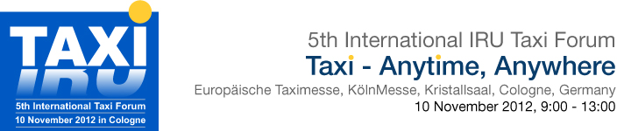
The Forum will be preceded by the 1st International Taxi Business Reception, to take place on 9 November 2012, in Köln, starting at 18:30 at the Rheinterrassen, Rheinparkweg 1, 50679 Köln-Deutz. All IRU Members and their operators present in Cologne, and all Forum participants are invited to join the Gathering

Forum Programme
Moderated by Oleg Kamberski (IRU)
Working languages: English, German, Russian
Registration is free of charge
8:30 | Welcome coffee
9:00 | Opening
Peter Zander,
President, Europäische Taximesse
Thomas Grätz,
Managing Director, BZP and Vice President IRU Taxi Group
Intervention from the IRU International Taxi Forum official partner,
Nissan Europe SAS
1st interactive session: Taxi – Anytime, Anywhere: Why?
The Customer First: Results and recommendations of the EuroTest survey on taxi service quality in 22 European cities
Luca Pascotto, Director of Mobility, Fédération Internationale de l’Automobile (FIA)
The Taxi as Part of the Public Transport Chain: Results of the “Collecto” night taxi service in Brussels and prospects for the future
Kristof De Mesmaeker, Adviser, Cabinet of Minister Brigitte Grouwels, Public Works, Transport, Port of Brussels, Information Policy, Brussels-Capital Region

Taxi - the flexibility champion: Best practices from around the world
Wim Faber, Specialist journalist (taxis) and Director/Co-founder Taxi Research Network
2nd interactive session: Taxi – Anytime, Anywhere: How?
Access to the Profession: The UK and London recipe for high quality taxi services
Roger J. Silvers, MA, LL.M, , RJS Management Services Limited
Professional Training: The royal path to quality of services
Patrick Philipp, Head, IRU Training Academy
The Appeal of Technology: Opportunities and threats
James Cooper, PhD, Transport Research Institute, Edinburgh Napier University, Director, Taxi Research Network and Richard Darberra, Director of the IVM (Cities on the Move) Taxi Research Program, Taxi Research Network
3rd interactive session: Taxi – Anytime, Anywhere: The role of authorities
The state’s policy in the field of taxis services regulation in Russia
Vyacheslav Lysakov. Chairman of the Board, National Taxi Council of Russia, First Deputy Chairman, The State Duma Committee for Constitutional Legislation
The City and the Taxi: Combining industry initiative and business friendly regulation
Prof. Dr. Mustafa Ilıcalı, Senior Advisor to Lord Mayor of Istanbul, and President of Bahçeşehir University Transportation Research Center, Istanbul Turkey
The Law and the Taxi: The right regulatory mix – the challenge of emerging technologies and smart phone applications
Matthew Daus, President, International Association of Transportation Regulators (IATR)
12:45-13:00 | Conclusions
 | Hubert Andela, IRU Taxi Group President
13:00–14:30 | Walking lunch - Offered by the official Forum partner, Nissan Europe SAS

