Press invitation
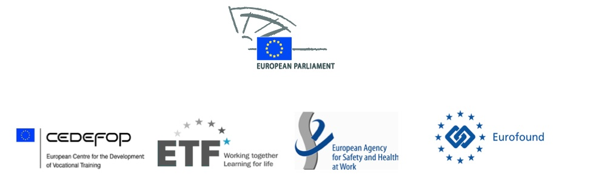

Four EU agencies - Cedefop, ETF, Eurofound and EU-OSHA – and the EP Employment and Social Affairs Committee are joining forces on 25 September 2013 to examine and highlight how each one is contributing to a strengthened European Social Model – in its own unique way. Assessing how exactly the European Social Model can contribute to increased competitiveness, the Agencies will provide different perspectives in the context of the current crisis. Considering the challenges for Europe’s businesses, workers and young people, the Agencies will present a multidimensional approach to a better and more sustainable future for the Europe of tomorrow.

Event: ‘The European Social Model – a key driver for competitiveness, the four EU Agencies’ contributions’, ioint seminar EP Employment and Social Affairs Committee - EU Agencies Cedefop, ETF, EU-OSHA, and Eurofound.

Date & time: 9.00 – 12.30, 25 September 2013, followed by a reception (12.30 – 13.30).
Venue: European Parliament, rue Wiertz 60, Brussels, room JAN 4Q2

Confirmed speakers at the event include:
- Mr László Andor, Commissioner for Employment, Social Affairs and Inclusion, European Commission
- Ms Pervenche Berès, Chair of the Committee on Employment and Social Affairs, European Parliament
- Ms Inês Cristina Zuber, Vice-Chair of the Committee on Employment and Social Affairs, European Parliament
- Mr Christian Lettmayr, Acting Director, Cedefop
- Ms Madlen Serban, Director, ETF
- Ms Christa Sedlatschek, Director, EU-OSHA
- Mr Juan Menéndez-Valdés, Director, Eurofound

There will be interview opportunities after the event.
The event will be hosted by the European Parliament’s Employment and Social Affairs Committee and will present the latest insights and work from the four agencies. In addition, experts from the world of work, academia and politics will be invited to debate the latest trends and consider how the EU Social Model can and does contribute to the improvement of the current social and economic landscape, ensuring a sustainable and competitive future.
The European Centre for the Development of Vocational Training (Cedefop) will demonstrate how Europe must get the best out of its people in order to be competitive. Not only does this require education and training systems to focus on people’s skills, (key) competences and entrepreneurial spirit – but they also need an inbuilt capacity to respond rapidly to the changing needs of the labour market.
The European Training Foundation (ETF) will focus on the importance of the EU external relations context, providing clear evidence that improved education and training in the neighbouring countries of the EU enhance employability, competitiveness and entrepreneurship. The ETF will show how sustainable development through human capital development is essential for improved economic performance.
With the European Social Model at the very core of its work, the European Foundation for the Improvement of Living and Working Conditions (Eurofound) will highlight its research in a range of key areas: labour market analysis - where the jobs have been lost and gained: how trends in working conditions and new ways of organising work can impact on productivity; measures to tackle the cost of youth unemployment; how public services are set to respond in times of crisis; the progress towards sustainable work and the key role of social dialogue in helping Europe on the path to recovery.
And finally, the European Agency for Safety and Health at Work (EU-OSHA) will convincingly demonstrate that at enterprise level, effective management of health and safety makes sound economic sense. Workplaces which are healthy and safe, with motivated managers and workers who are involved are more productive, contribute to a sustainable strengthening of Europe’s competitiveness.
The Employment and Social Affairs Committee of the European Parliament (EMPL) is mainly responsible for employment policies and all aspects of social policy, working conditions, vocational training, EU social programmes, social dialogue, free movement of workers and pensioners as well as relations with European agencies acting in employment and social related fields. The Committee works with the Council of the Union and the European Commission to implement the legislative framework in the areas for which it is responsible. During the current parliamentary term, the Committee is seeking to drive forward a new Social Agenda and to contribute to promoting a more inclusive society.

To register for the event, and for more information, contact:
- Ms Rosy Voudouri, Press and News Service, Cedefop, on email: rosy.voudouri@cedefop.europa.eu or mobile: + 30 694 441 3216 or +44 774 0818 778.
- Mr Bent Sorensen, Head of Communication, ETF, on email: bent.sorensen@etf.europa.eu or mobile: +39 347 970 1648.
- Ms Brenda O’Brien, Brussels Liaison Office, EU-OSHA, email: obrien@osha.europa.eu or mobile: +32 477 175 770.
- Mr Måns Mårtensson, Media Manager, Eurofound, on email: mma@eurofound.europa.eu or mobile: +353 876 593 507.

